|  |  |  |
| --- | --- | --- |
| SCHOOL OF INFORMATION TECHNOLOGY | | |
| NAME: John Ross S. Sabado | |  |
| SECTION: IDC2 | DATE SUBMITTED: |

# (COURSE CODE) PORTFOLIO

**Table of Contents**

|  |  |  |  |
| --- | --- | --- | --- |
| **Name of Activities** | **Date** | **Score** | **Page No.** |
| **First Grading** | | | |
| Quizzes | | | |
| Quiz 1 | Sep. 21 2024 | 24/30 | 3 |
| Other Activities | | | |
| Seatwork 1 | Aug. 20 2024 | 18/20 | 3 |
| FGE_LW4 Managing Services in Linux | Sep. 12 2024 | No data | 4 |
| First Grading Exam | Sep. 18 2024 | 31/60 | 4 |
| **Midterms** | | | |
| Other Activities | | | |
| M_LW1 Print Services | No data | No data | 5 |
| M_LW2 Web Server | No data | No data | 5 |
| M_LW3 Platform Services | No data | No data | 6 |
| Midterm Exam | Nov 7 2024 | Lec 44  Lab 54 | 6 |
| **Finals** | | | |
| Other Activities | | | |
| Capacity management planning | Nov 28 2024 | 30/30 | 7 |
| FQuiz1_Recovery | Nov. 21 2024 | No data | 7 |
| FLW Git | Nov. 21 2024 | No data | 8 |
| Final Exam | No data | No data | --------- |
| Course Reflection |  |  | 9 |

**First Grading**

**Quiz 1:**

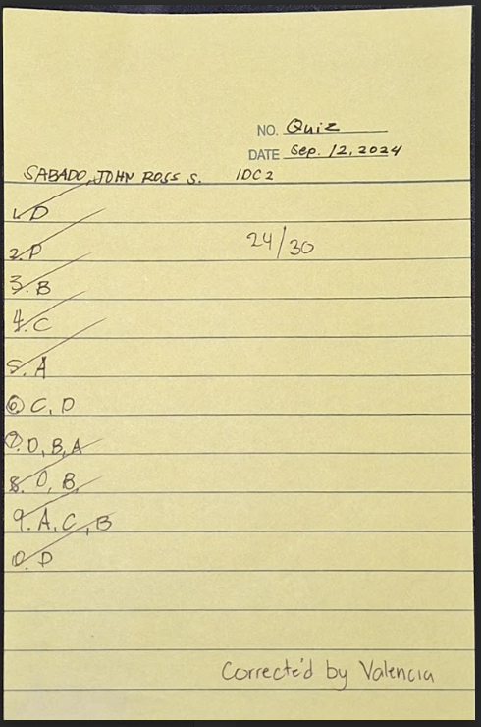

**Seatwork 1:**

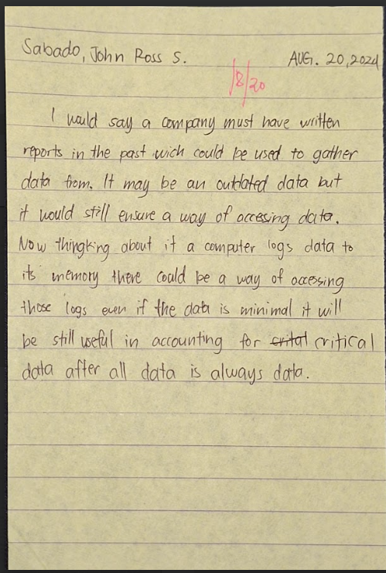

**FGE_LW4 Managing Services in Linux**

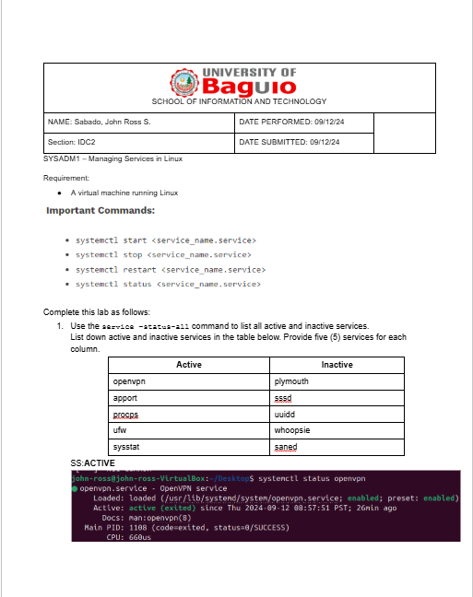

**First Grading Exam**

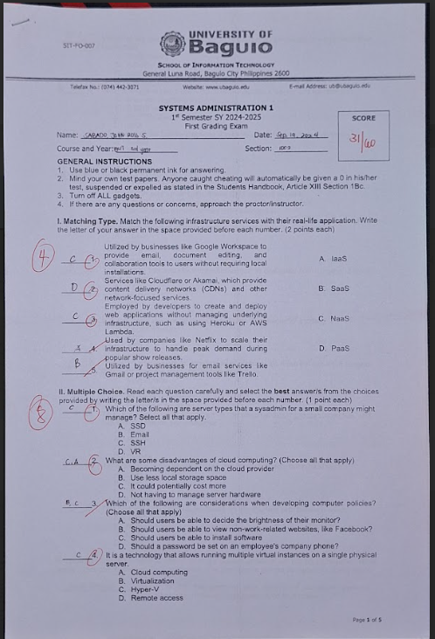

**Midterms:**

**M_LW1 Print Services**

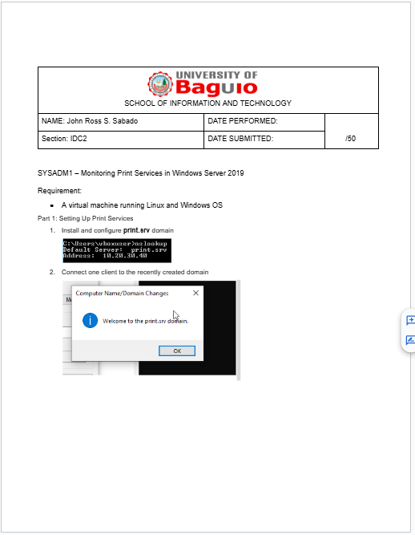

**M_LW2 Web Server**

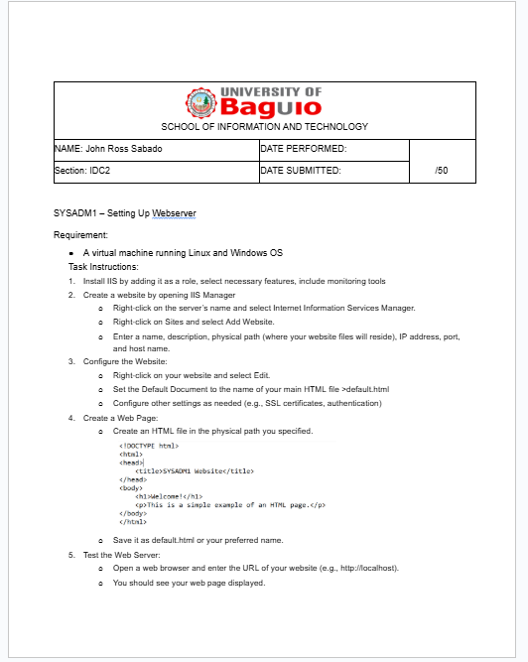

**M_LW3 Platform Services**

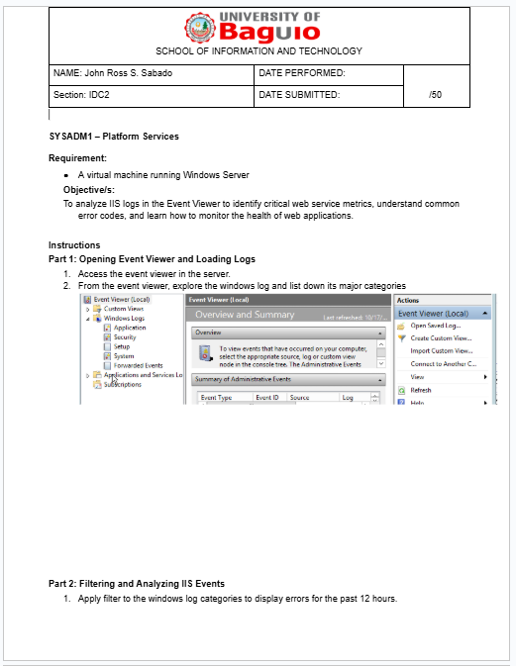

**Midterm Exam**

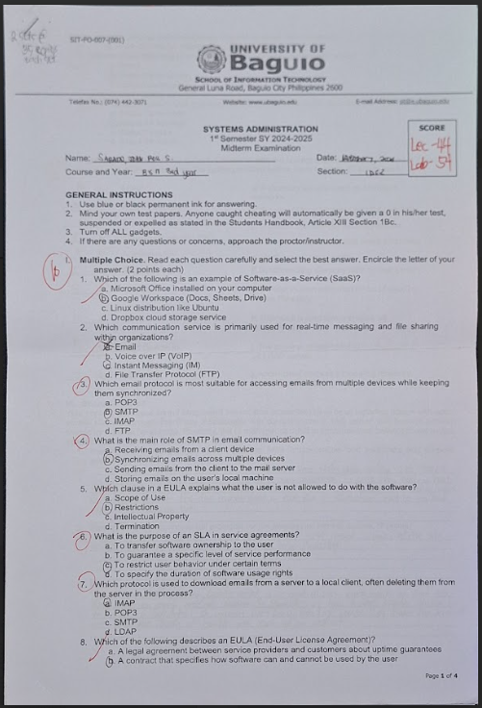

**Finals**

**Capacity management planning**

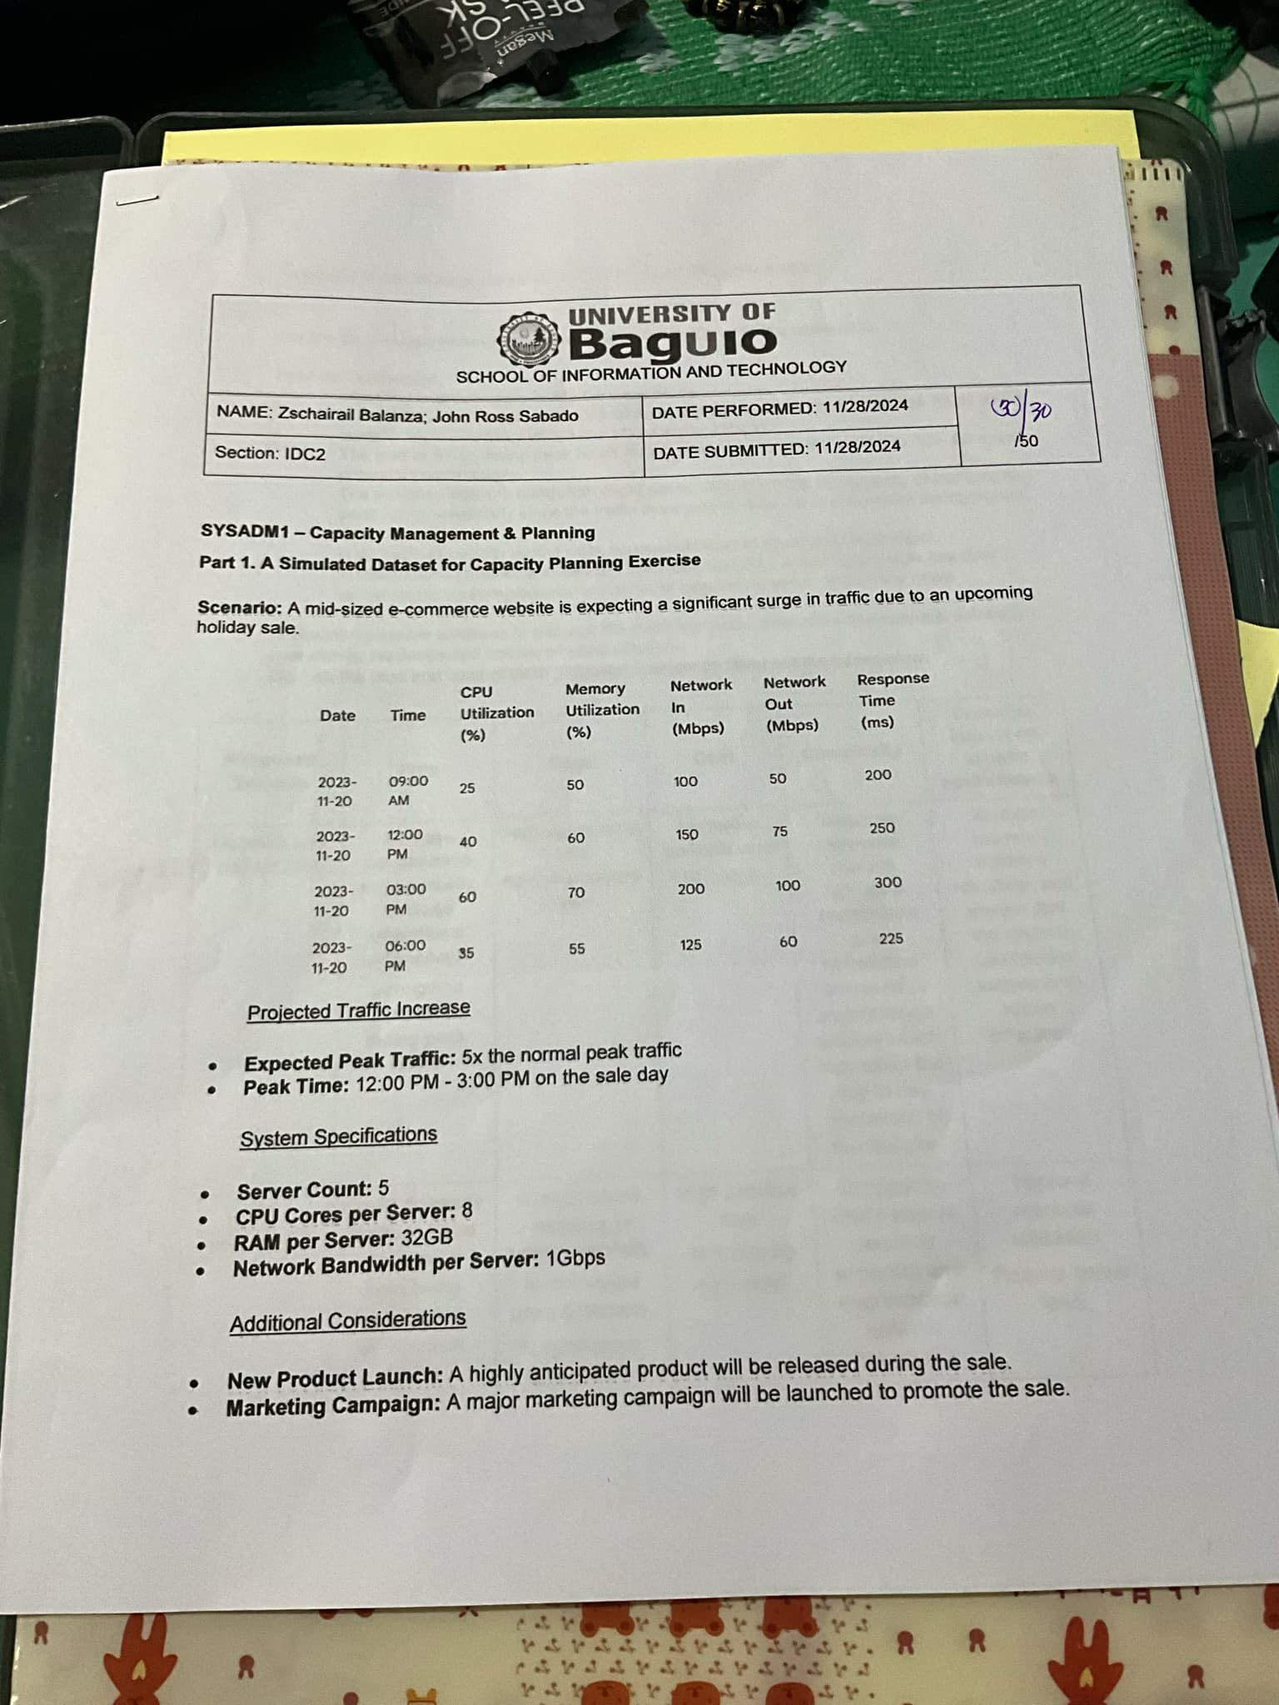

**FQuiz1_Recovery**

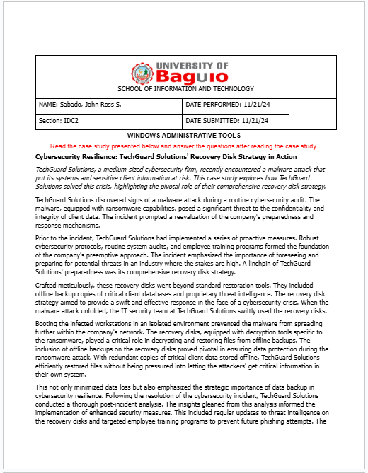

**FLW Git**

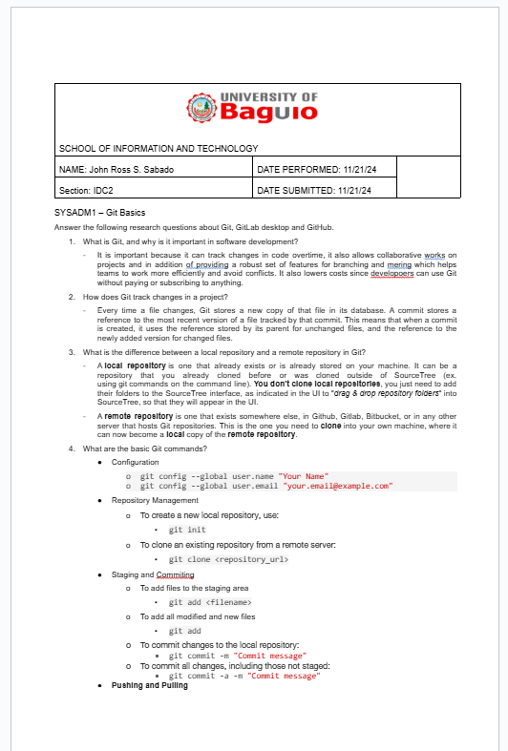

**Course Reflection**

What were your initial expectations for the course? Did the course meet, exceed, or fall short of these expectations?

|  |
| --- |
| I expected to gain a solid foundation in managing servers, configuring networks, and handling day-to-day administrative tasks like user management and security protocols. My expectation was that the course would prepare me to troubleshoot and optimize IT systems effectively. The course met and, in some areas, exceeded these expectations, especially with the hands-on labs and real-world scenarios we tackled. |

What were the main topics or concepts covered in the course? How did these topics contribute to your understanding of the subject matter?

|  |
| --- |
| Learning about automation and scripting, especially using PowerShell and Bash, was particularly impactful as it showed how to streamline repetitive tasks. |

Reflecting on your learning process, what were the most effective strategies or techniques that helped you grasp and retain the course material?

|  |
| --- |
| One of the most effective strategies for me was active participation in lab sessions. Setting up virtual environments to simulate real-world scenarios helped reinforce theoretical concepts. I also found that creating step-by-step guides for tasks during the labs improved my retention and understanding. |

Were there any particular assignments, projects, or activities that significantly enhanced your learning experience? Why were they effective?

|  |
| --- |
| Nothing much since I had a grasp of the subject and kept up with it |

Did you encounter any challenges or difficulties during the course? How did you overcome these obstacles, and what did you learn from them?

|  |
| --- |
| Assignments like comparing different security protocols required evaluating pros and cons to make informed decisions, enhancing our problem-solving and decision-making skills. Troubleshooting labs pushed us to think beyond surface-level solutions |

Did the course encourage critical thinking and analysis? How did it promote higher-order thinking skills, such as problem-solving or decision-making?

|  |
| --- |
| It improved my technical and problem-solving skills. |

Reflecting on your personal growth, what new knowledge, skills, or perspectives did you gain from this course?

|  |
| --- |
| It showed me that when a road block presents it self there would still be a way around it. So is a firewall, so when facing system problems its best to stop and take a break and then get back right into it |

How do you plan to apply what you have learned in this course to your future studies, career, or personal life?

|  |
| --- |
| I gained will also help me manage personal servers and contribute to collaborative IT projects more effectively. |